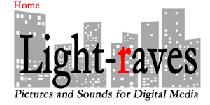

Lighting and Camera for Digital Media

Bruce Lundeen is Light-raves, a Lighting Cameraman - Doc shooter

Bruce makes moving digital photography - a/k/a video, all over the world, with a small portable kit, usually with no less than 3 different kinds of cameras used for their best attributes. Cameras are chosen for the job, changing often as photographic technology advances and storytelling gets more exciting. Along with his kit Bruce brings his unique approach to every shoot - his ability to capture the moment and connect with his subjects. High energy, inspiration, joy, field acquisition that exceeds expectations, and unparalleled camera coverage allow full freedom of creative expression for the director in the edit booth. Bruce makes great choices in the field - with the experience to make sure the production gets the shot - even if it’s only happening once.

Light-raves' business model is simple: collaboration, trust, humor and redundant media storage. Bruce believes in putting the client first, ego second, always having a spare everything, and changing the world one tripod mark at a time. Light-raves can supply crews in small and large settings - we have a willing and able cadre of audio techs, teleprompter operators, jib operators, make-up artists, and whatever it takes to help you tell the story, from Cats 101 to the street children of Rio de Janeiro. The value added is the value of experience, flexibility, compassion, extra batteries and extra hard drives. We understand the constraints of budget and time, believing the technical is there for the story and not the other way around. Light-raves will help your story shine with a truckload of lights or available light and the resources at hand.

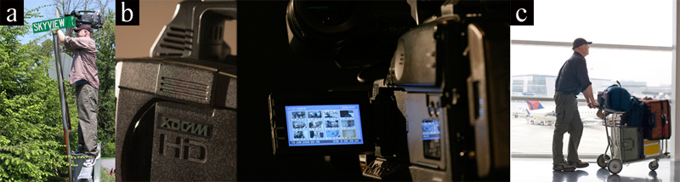
Photo Captions: (a."Will go where-ever the shot is, knowing there is an inverse relationship between comfort and quality."- b."7 seasons of experience with xdcam pdw 350 and 355, EX1r, and now the PDW700 - file based shooting with a xdcam disc as an archive."- c."Full production kit with camera, tripod, chimera lighting and audio package - on an airport cart, 2 carry-ons and 2 checked bags - now this is traveling light!").

What We Provide Our Clients:
-International shooting packages with full crew
-Studio lighting set-up
-Ultimatte & other Key shoots
-High Tech medical
-Documentary story gathering
-Reality TV
-Detail exterior & interior automobile
-Traveling shots
-Press conferences
-Sports events
-Live shots
-Vehicles, cameras, audio and lighting equipment
-and More ...

Some Of Our Projects Include:
-Helicopter footage for Captains of Industry promotion of FirstWind Maine wind turbines
-Lighting for BU Hockey Plazmatron
-Principal photography for Land Rover LR3 Owner's Manual on DVD
-Institute of Technical Education Singapore, Kennedy School of Business Innovations in Government
-Arryz nanophotonics and microminiaturization products for medical science
-Rolls Royce in Carmel California

©2012 www.light-raves.com / (781)883-5300 / bruce@light-raves.com

